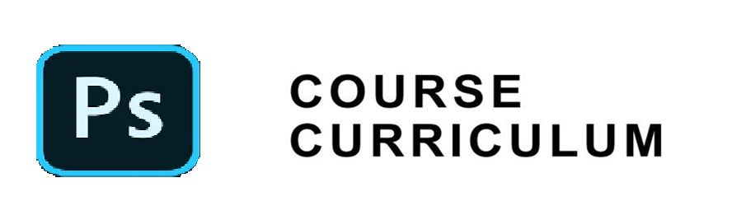

|  |  |
| --- | --- |
| **Month 1 : Photoshop for beginners** | |
|  | |
| **Week 1** | |
| Day 1 | Introduction to Adobe Photoshop Interface |
| Day 2 | Understanding Basic Tools and Workspace Customization |
| Project | Design a simple logo using basic shapes and text tools |
|  | |
| **Week 2** | |
| Day 3 | Working with Layers and Layer Styles |
| Day 4 | Image Editing Techniques: Cropping, Resizing, and Rotating |
| Project | Edit a landscape photo by combining multiple layers and applying layer styles for a creative effect |
|  | |
| **Week 3** | |
| Day 5 | Understanding Selection Tools and Techniques |
| Day 6 | Introduction to Color Correction and Adjustment Layers |
| Project | Create a composite image by selecting and combining elements from multiple photos, and apply color correction to unify the composition |
|  | |
| **Week 4** | |
| Day 7 | Text and Typography in Photoshop |
| Day 8 | Introduction to Filters and Special Effects |
| Project | Design a magazine cover layout with styled text and apply artistic filters for a visually appealing cover |
|  | |

|  |  |
| --- | --- |
| **Month 2: Delving deeper** | |
|  | |
| **Week 5** | |
| Day 9 | Advanced Selection Techniques and Masking |
| Day 10 | Working with Brushes and Brush Presets |
| Project | Create a digital portrait by mastering selection tools and using custom brushes for realistic details |
|  | |
| **Week 6** | |
| Day 11 | Advanced Layer Management and Grouping |
| Day 12 | Image Retouching and Photo Restoration Techniques |
| Project | Restore an old family photo by retouching damaged areas, adjusting colors, and preserving original details |
|  | |
| **Week 7** | |
| Day 13 | Advanced Color Correction and Gradients |
| Day 14 | Introduction to 3D Tools and Features |
| Project | Design a 3D text logo with gradient effects and explore basic 3D features like extrusion and lighting |
|  | |
| **Week 8 : Advanced Topics and Deployment** | |
| Day 15 | Exporting and Saving for Web and Print |
| Day 16 | Explore creative editing methods like double exposures |
| Project | Designing a Poster or Digital Artwork |